Taylor Larrechea

Dr. Gustafson

Math 362 Fourier Analysis

November 7, 2017

Ch. 5.2

Section 5.2

5.2.8

For the matrices $A$ given, do the following.

1. Find the 2D DCT II and 2D IDCT II transforms using hand calculations as in Example 5.2.3. Show all work.
2. Find the 2D DCT II and 2D IDCT II transforms using MATLAB as in Example 5.2.4. Show all MATLAB commands used.

a.)

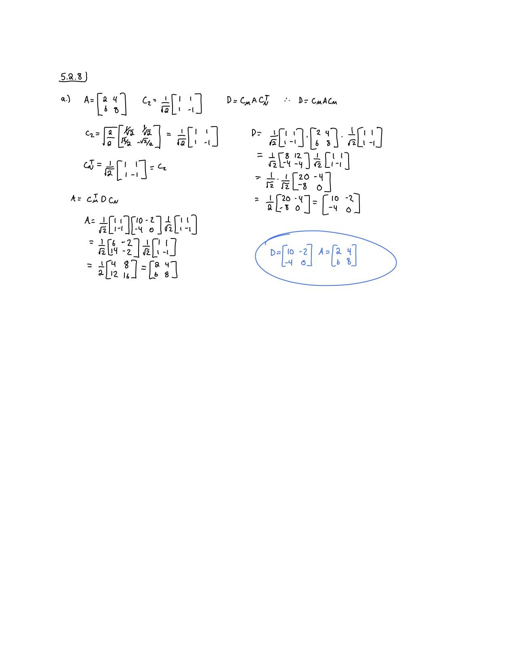

b.)

|  |  |
| --- | --- |
| Input Commands | Output (Plot if Applicable) |
| >> A=[2,4;6,8];  >> C=1/sqrt(2)*[1,1;1,-1];  >> D=C*A*C'  >> C=1/sqrt(2)*[1,1;1,-1];  >> D=[10,-2;-4,0];  >> A1=C*D*C' | D =  10.0000 -2.0000  -4.0000 0  A1 =  2.0000 4.0000  6.0000 8.0000 |

5.2.16

For the matrices $A$ given, find the 2D DCT II transform of $A$ using dct4x4(A) as in Example 5.2.5. Show all MATLAB commands used.

|  |  |
| --- | --- |
| Input Commands | Output (Plot if Applicable) |
| >> A=[1,0,1,3;-1,2,1,1;1,1,4,-2;0,3,1,1];  >> dct4x4(A) | D =  4.2500 -0.7886 -2.2500 0.0561  -0.1353 -1.5482 2.3658 0.0304  0.7500 -0.9007 2.2500 -1.5212  0.3267 1.0304 -0.1682 3.0482 |